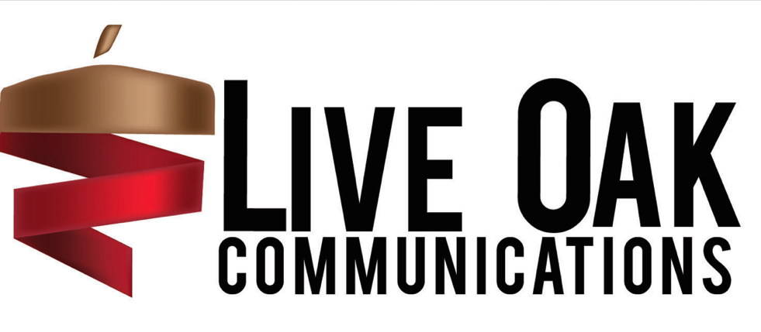
APPLICATION FOR FALL 2022 SEMESTER
POSITION: ASSISTANT AGENCY DIRECTOR
EMAIL ALL MATERIALS BY APRIL 14TH at 5:00PM TO MANAGEMENT.LIVEOAK@GMAIL.COM

In addition to the below application, please send a copy of your COVER LETTER AND RESUME.
Open to rising juniors. (Two semester position)
Incomplete applications will not be considered.
APPLICANT NAME:
YEAR:
MAJOR(S):
MINOR(S):
CURRENT GPA:
DATATEL #:
EMAIL ADDRESS:
PHONE NUMBER:
You are encouraged to provide your online portfolio or LinkedIn URL if you have one, but this is not a mandatory component of the application:

Please list a reference in the School of Communications who could attest to the competency of your skills that would be required to succeed in this position:

What new ideas do you have for the agency in the upcoming year?

Describe a time in which you had to compromise with a group? What happened? How did you handle it?

What would you contribute to the agency if you were Assistant Director?

